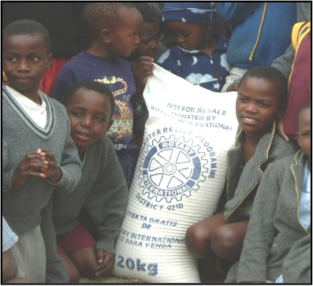
Your Donations Can Provide
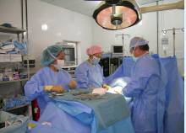
Surgical equipment for Guatemala Feeding the hungry

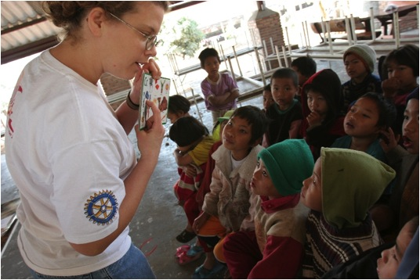
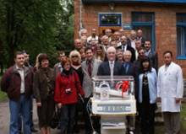
Neonatal incubators for Ukraine rural hospitals Providing educational opportunities

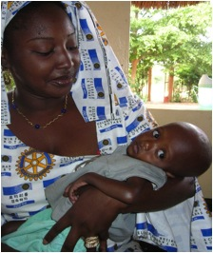
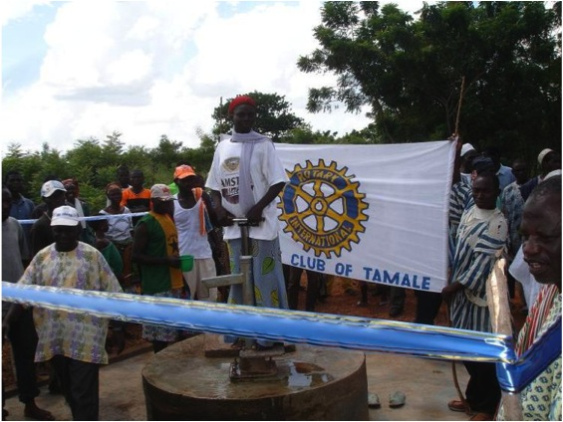

Clean water for a village in Ghana Providing health care for mothers & children

